LAB EXPERIMENTS
CSA1003 SOFTWARE ENGINEERING
Name : Keerthana.G
Reg no:192521446
Department:IT
JIRA SOFTWARE
1. Create a Kanban Board to Visualize the Tasks.
• Create Columns for To Do, In-Progress and Done.
• Add Atleast 5 Sample Tasks
• Move the Tasks across the Columns to Simulate the Workflow.
https://gkeerthi740.atlassian.net/jira/software/c/projects/TM/boards/69

1.Navigate to the Board section to access the Kanban board.

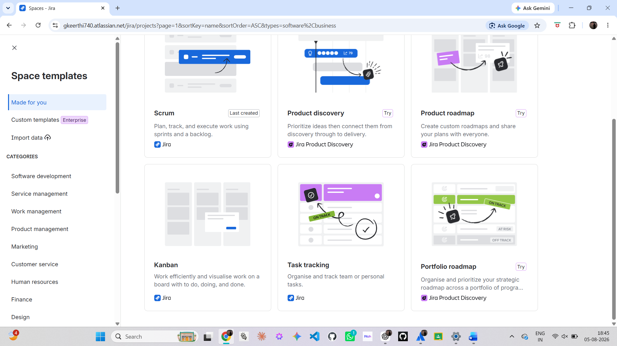

2. Select the Kanban template and use the template
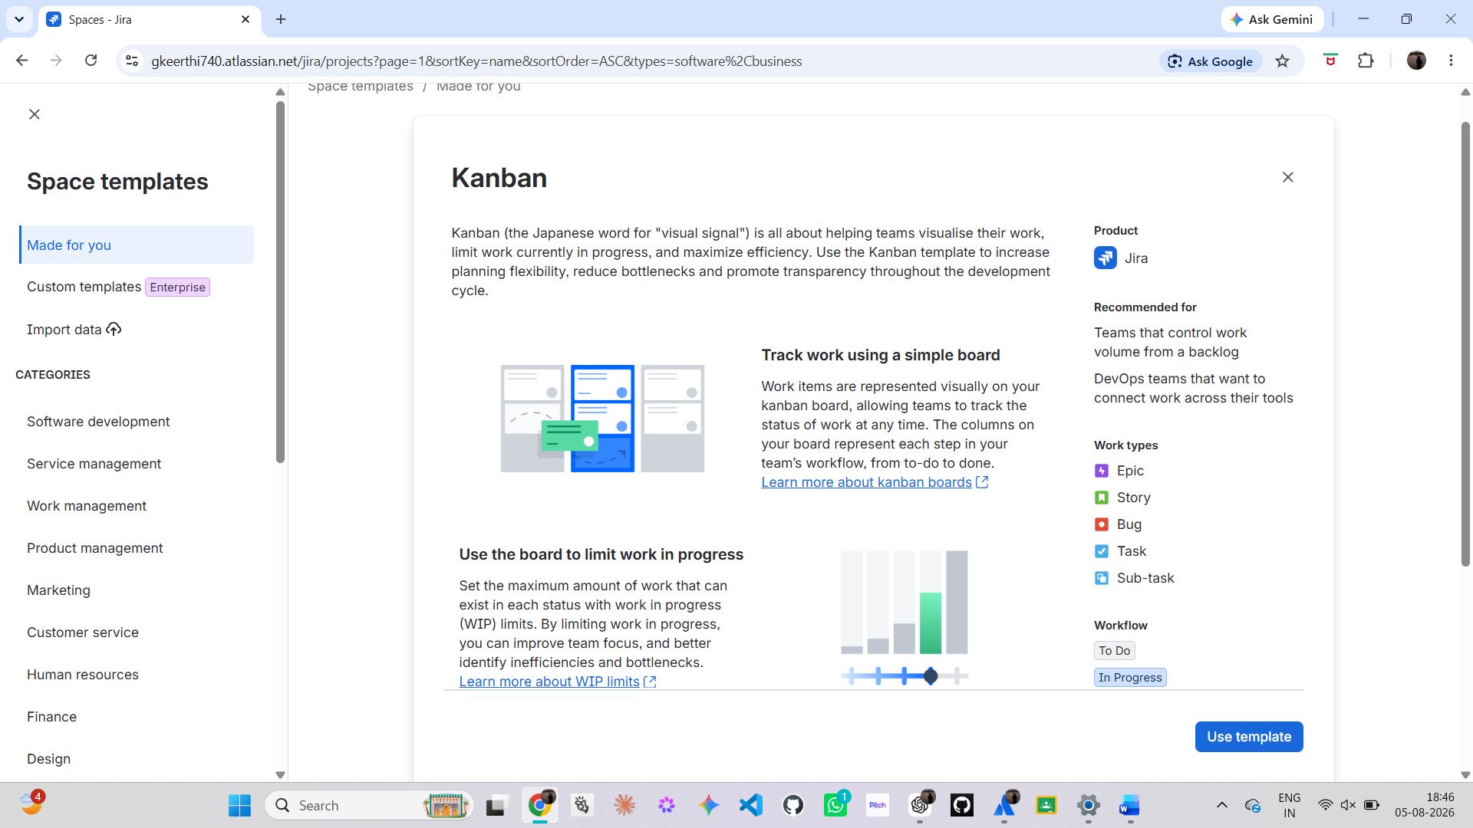

3.Click the Create button to add a new task.
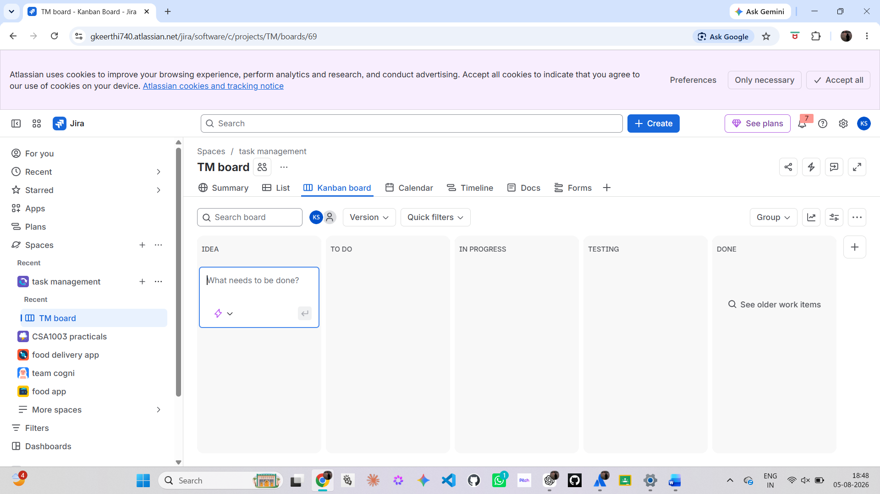

4.Enter the task name in the Summary field and click Create.

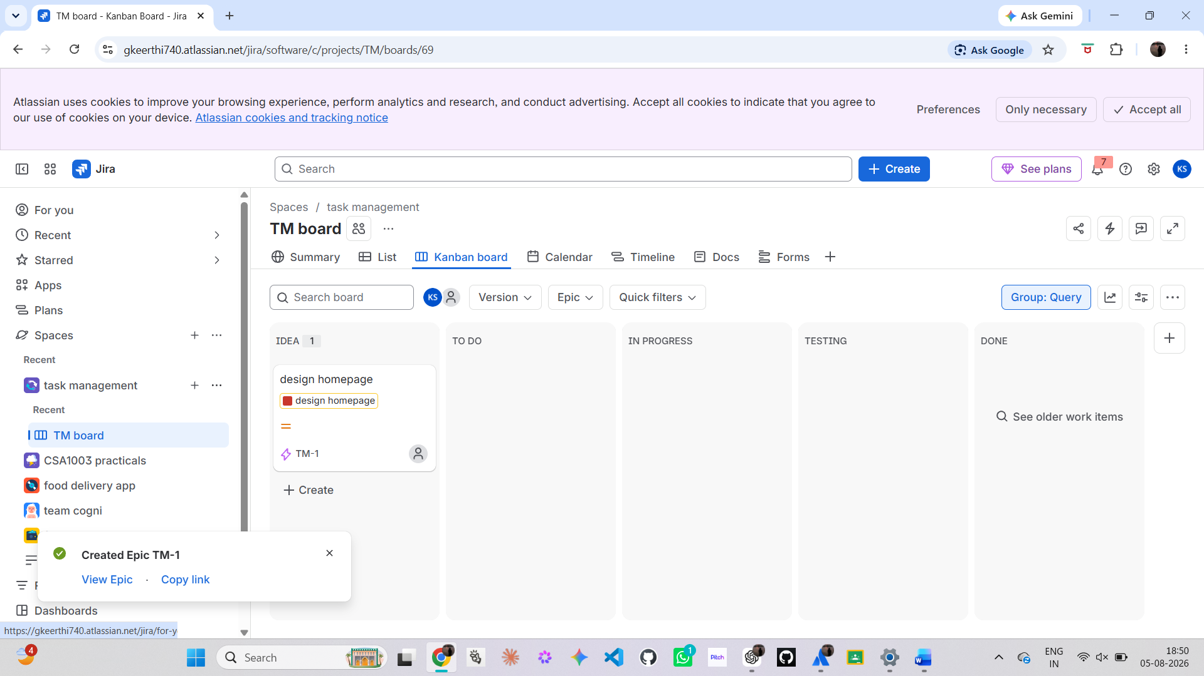

5. Verify that all tasks are displayed in the Idea or To Do column.

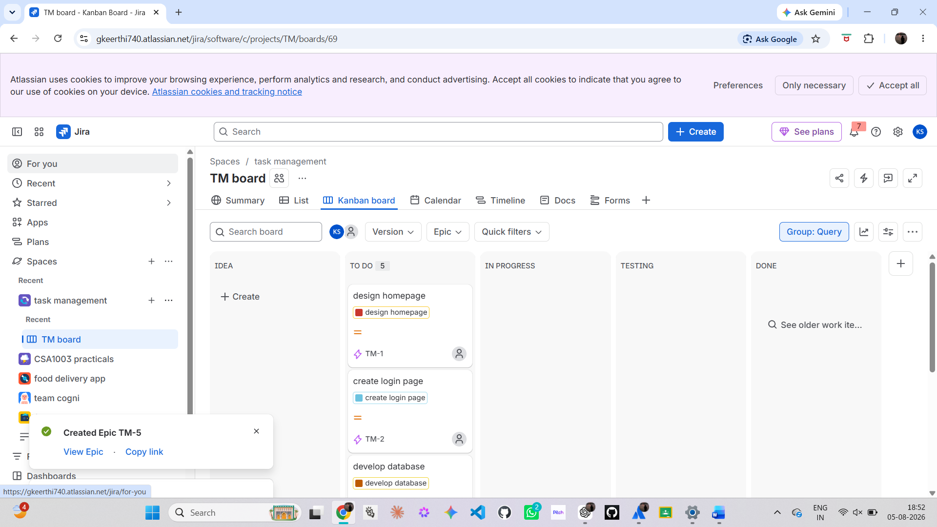

6. Move the tasks from To Do to In Progress.

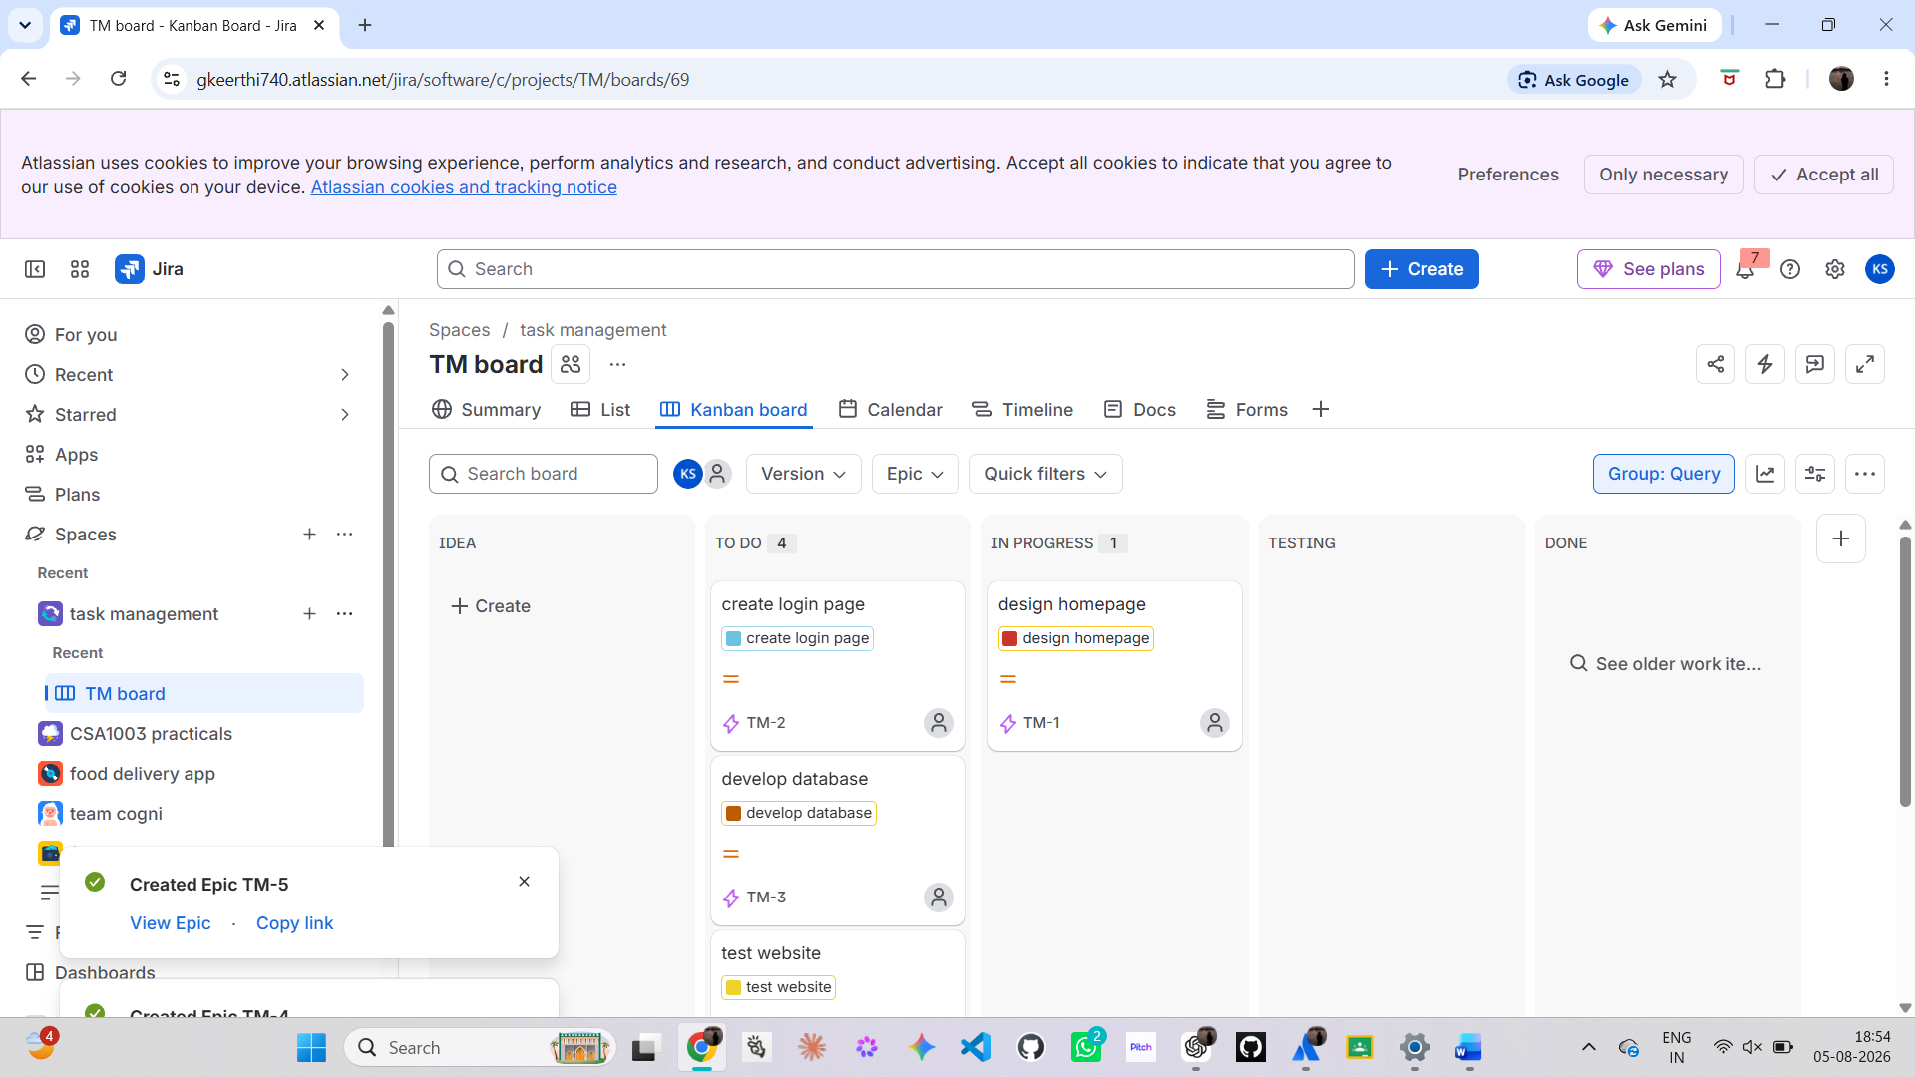

7.Drag all the tasks to in progress

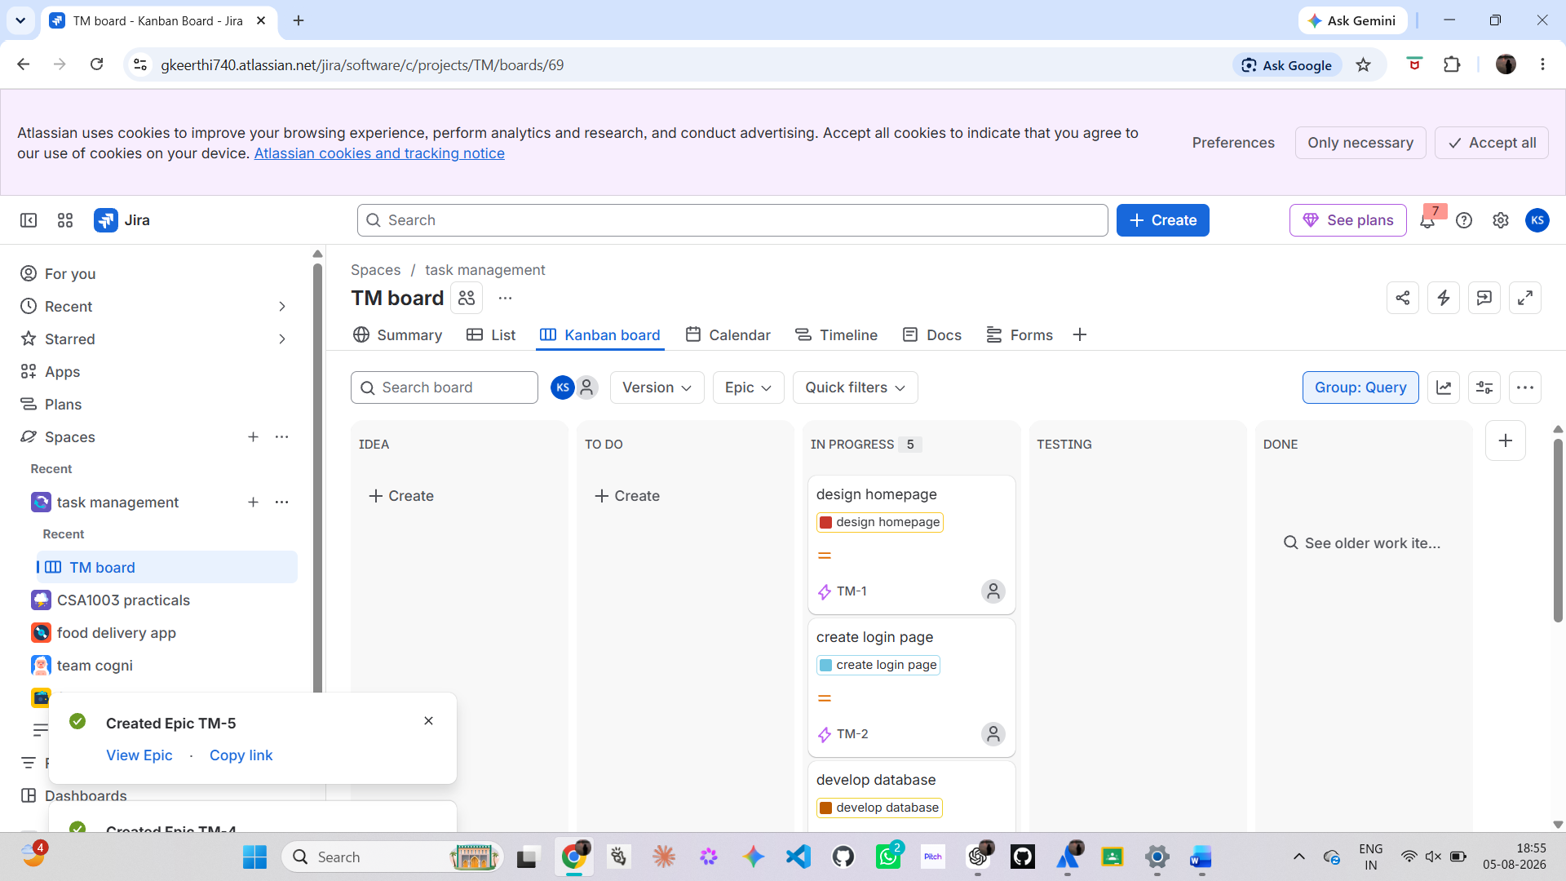

8. Drag the tasks from In Progress to Testing

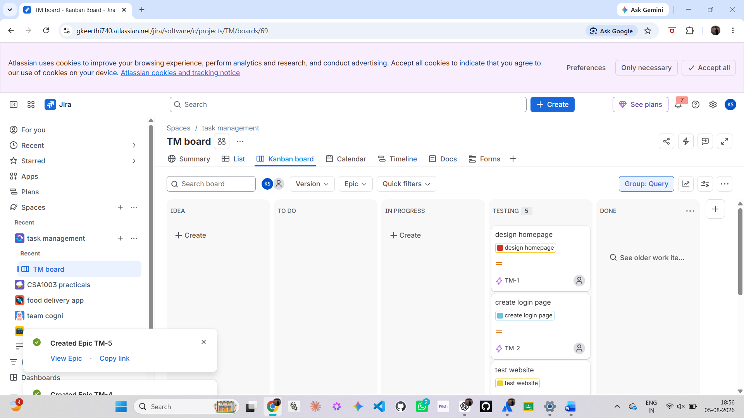

9. Finally, move all tasks from Testing to Done

